Week 6
Implement a program with basic commands on databases and collections using MongoDB
Step 1: Download and Install MongoDB on Windows
- Go to the official MongoDB Community Download page: MongoDB Download Center ( https://www.mongodb.com/try/download/community )
- Choose:
  - Version: Latest stable
  - Platform: Windows
  - Package: MSI
- Run the .msi installer:
  - Select Complete installation.
  - Check the option Install MongoDB as a Service (so it runs automatically).
  - Optionally install MongoDB Compass (GUI) for exploring data.
- After installation, MongoDB runs as a Windows service.
Step 2: Install MongoDB Shell (mongosh)
- Download the MongoDB Shell (mongosh) from: MongoDB Shell Download (https://www.mongodb.com/try/download/shell)
- Run the installer.
- Verify installation: open Command Prompt (cmd) or PowerShell:
mongosh –version

Step 3: Start the Shell and Connect
Open Command Prompt and type:
Mongosh

If installed as a service, MongoDB is already running at localhost:27017.
it diaplays the following code:
Current Mongosh Log ID: ...
Connecting to: mongodb://127.0.0.1:27017/?directConnection=true
Using MongoDB: <version>

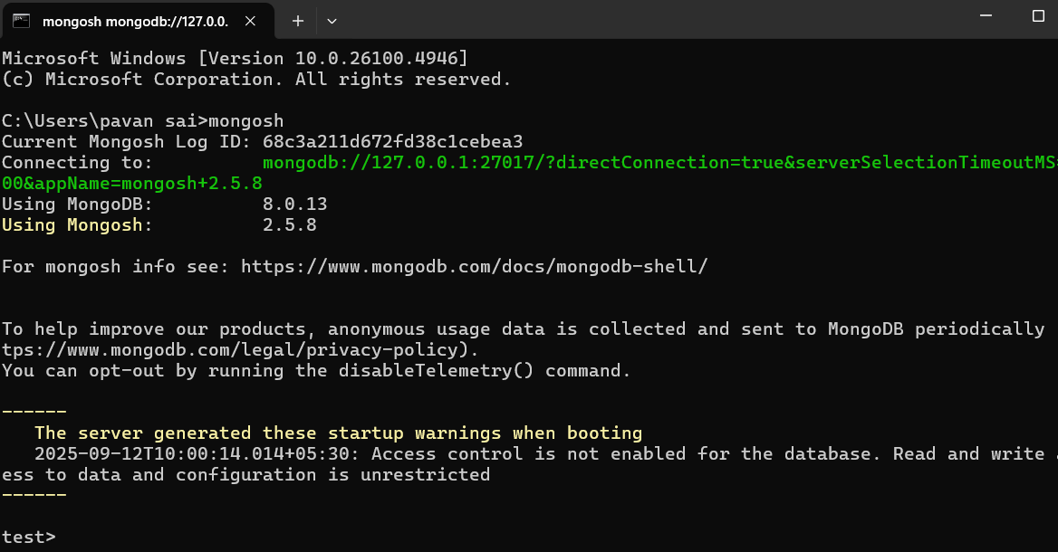

Basic Database Commands

1) MongoDB Help: To get a list of commands, type db.help() in MongoDB client: db.help
2) Show All Databases: to get list of all databases : show dbs
3) Create new database: To create a new database: use DATABASE_NAME
4) Know your current selected database: To know your current working/selected database execute: db
5) Drop database: To drop the database execute: db.dropDatabase()
6) To create the new collection execute: db.createCollection(name)
7) To check collections list: To get the list of collections created execute : Show collections
8) Drop collection: To drop the selected collection execute : db.COLLECTION_NAME.drop()
9) Insert document in collection:
To insert single document in selected collection execute the following command
db.COLLECTION_NAME.insert(document)
To insert multiple documents in selected collection execute following command
db.COLLECTION_NAME.insertMany(documents)
10) Get collection document
To get the list documents in collection: db.COLLECTION_NAME.find().pretty()
11) Update document
To update the document in collection execute: db.COLLECTION_NAME.update(SELECTION_CRITERIA, UPDATED_DATA)
12) Delete document: To delete document in selected collection :db.COLLECTION_NAME.remove(DELLETION_CRITTERIA)

Create collection
// 1. Switch/create database
use college
// Output: switched to db college

// 2. Create collection (optional, auto-created on insert)
db.createCollection("students")

// 3. Insert documents
db.students.insertMany([
{name: "pavan", age: 20, dept: "CSE"},
{name: "Raghu", age: 21, dept: "CSE"},
{name: "Abhay", age: 22, dept: "ECE"}
])
// Output: acknowledged: true, insertedIds: { ... }

// 4. Display all documents
db.students.find().pretty()
// Output: JSON documents with _id, name, age, dept

// 5. Query with filter
db.students.find({dept:"CSE"})
// Output: only CSE related

// 6. Update a record
db.students.updateOne({name:"Abhay"}, {$set: {age:21}})
// Output: { acknowledged: true, matchedCount: 1, modifiedCount: 1 }

// 7. Delete a record
db.students.deleteOne({name:"pavan"})
// Output: { acknowledged: true, deletedCount: 1 }

// 8. Drop collection
db.students.drop()

// 9. Drop entire database
db.dropDatabase()

